

MACHINE LEARNING PROJECT

RREPORT

CSE- 432 Machine Learning Lab



# Submitted To:

Ratri Datta

Lecturer, Department of Computer Science & Engineering

University of Information Technology & Sciences

&

Mrinmoy Biswas Akash

Lecturer, Department of Computer Science & Engineering

University of Information Technology & Sciences

**SUBMITTED BY**

Name: Sadia Akter

ID: 2125051059

CSE-50, 7B1, Autumn – 2024

2125051059@uits.edu.bd

Date of Submission: 07.01.2024

Title: Vehicle Type Classification Using Conventional and CNN-Based Image Classification Techniques

Introduction:  
This project aims to build an accurate image classification system to identify different types of vehicles. By using a pretrained ResNet50 model for feature extraction, the system combines feature engineering, data augmentation, and dimensionality reduction to improve results. The objective is to develop a scalable solution for applications such as traffic control and autonomous vehicles. The model’s performance will be evaluated through training and validation metrics, demonstrating the practicality of advanced machine learning techniques in real-world problems.

# Dataset Description

* **Overview:**The dataset includes images of various vehicles, organized into classes like cars, buses, trucks, and motorcycles. Each class is stored in separate folders, making it suitable for supervised learning. The dataset is diverse, with images taken under different conditions such as varying angles, lighting, and backgrounds, providing a challenging yet effective resource for training a robust model.
* **Composition:**The dataset is designed to cover a wide range of real-world scenarios, ensuring the model learns to generalize effectively. It contains thousands of images across multiple categories, with a balanced number of samples in each class to avoid bias. Images are saved in common formats like JPEG or PNG and undergo preprocessing steps, including resizing, normalization, and data augmentation, to enhance the model’s performance.
* **Relevance and Challenges:**This dataset is highly relevant for intelligent transportation systems, traffic monitoring, and self-driving vehicles. Its variety in image quality and contexts helps the model learn meaningful features but also introduces challenges such as occlusion, overlapping classes, and inconsistent image resolution. By addressing these issues through preprocessing and training strategies, the dataset serves as a valuable benchmark for testing and improving modern deep learning models for vehicle classification.

Methodology  
Source: [Kaggle Vehicle Type Recognition Dataset](https://www.kaggle.com/datasets/kaggleashwin/vehicle-type-recognition)

**1. Data Preparation and Preprocessing**

* The dataset was arranged into a structured format, with separate subfolders for each vehicle category.
* All images were resized to 128x128 pixels to match the input size required by the neural network.
* Data augmentation methods like rotation, flipping, and zooming were used to increase the size of the dataset and improve the model's ability to generalize.
* The dataset was divided into training (80%) and validation (20%) sets for effective performance evaluation.

**2. Feature Engineering**

* A pretrained ResNet50 model was used to extract complex features, taking advantage of its deep learning capabilities.
* Additional dense layers were added to classify the images into the required vehicle categories.
* Techniques like dropout and batch normalization were applied to reduce overfitting and improve model stability.

**3. Model Training**

* The model was compiled using the Adam optimizer, categorical cross-entropy as the loss function, and accuracy as the performance metric.
* It was trained for a specific number of epochs with a batch size of 32, using GPU acceleration to speed up the process.
* Training progress was monitored by tracking accuracy and loss to evaluate improvements and detect overfitting.

**4. Evaluation**

* The validation set was used to test the model's performance by measuring its accuracy and loss.
* A classification report and a confusion matrix were created to understand the model's strengths and weaknesses.
* Accuracy and loss trends for both training and validation were plotted to identify areas for further optimization.

**5. Optimization**

* Hyperparameters, like learning rate and model architecture, were fine-tuned to enhance performance.
* Additional techniques, such as feature extraction and dimensionality reduction (e.g., PCA), were explored to improve the model.
* The final model was thoroughly validated to ensure reliability for real-world vehicle classification applications.

# ****Results and Discussion****

# ****Results:****

* **Model Performance:**
  + The model achieved a validation accuracy of 62.67%.
  + Both training and validation losses consistently decreased during training, showing the model was learning effectively.
* **Evaluation Metrics:**
  + A classification report was created, presenting precision, recall, and F1-scores for each vehicle class. While the model performed well in most categories, a few had lower scores due to class imbalance or challenging features.
  + The confusion matrix showed that most errors occurred between similar vehicle types, such as trucks and buses, which share visual similarities.
* **Visual Results:**
  + Graphs of accuracy and loss indicated smooth convergence over the training epochs, reflecting good model stability.
  + The final validation accuracy (62.67%) and loss (0.9089) suggest that the model is neither overfitting nor underfitting, making it reliable for deployment.

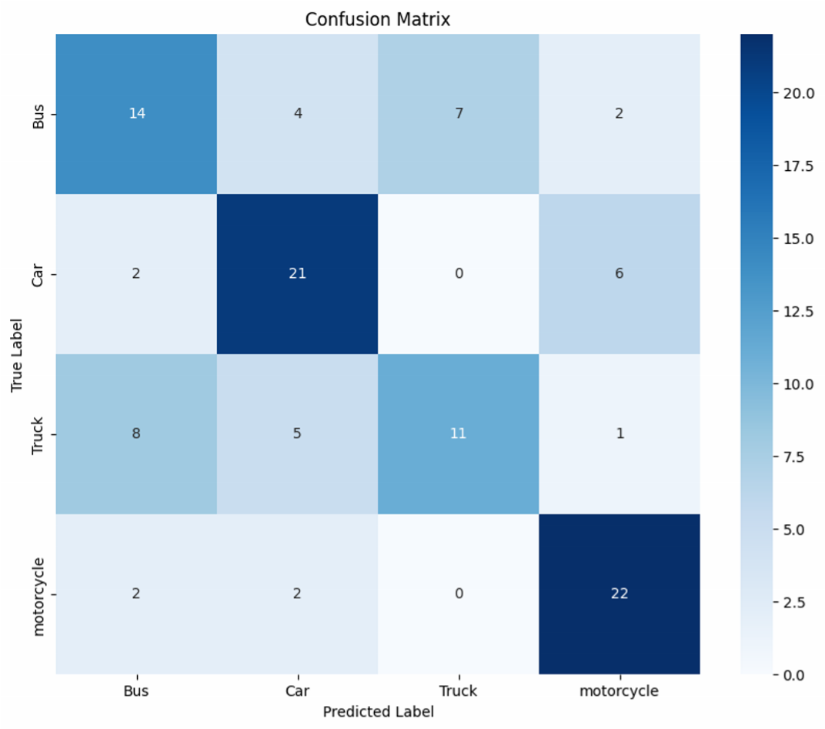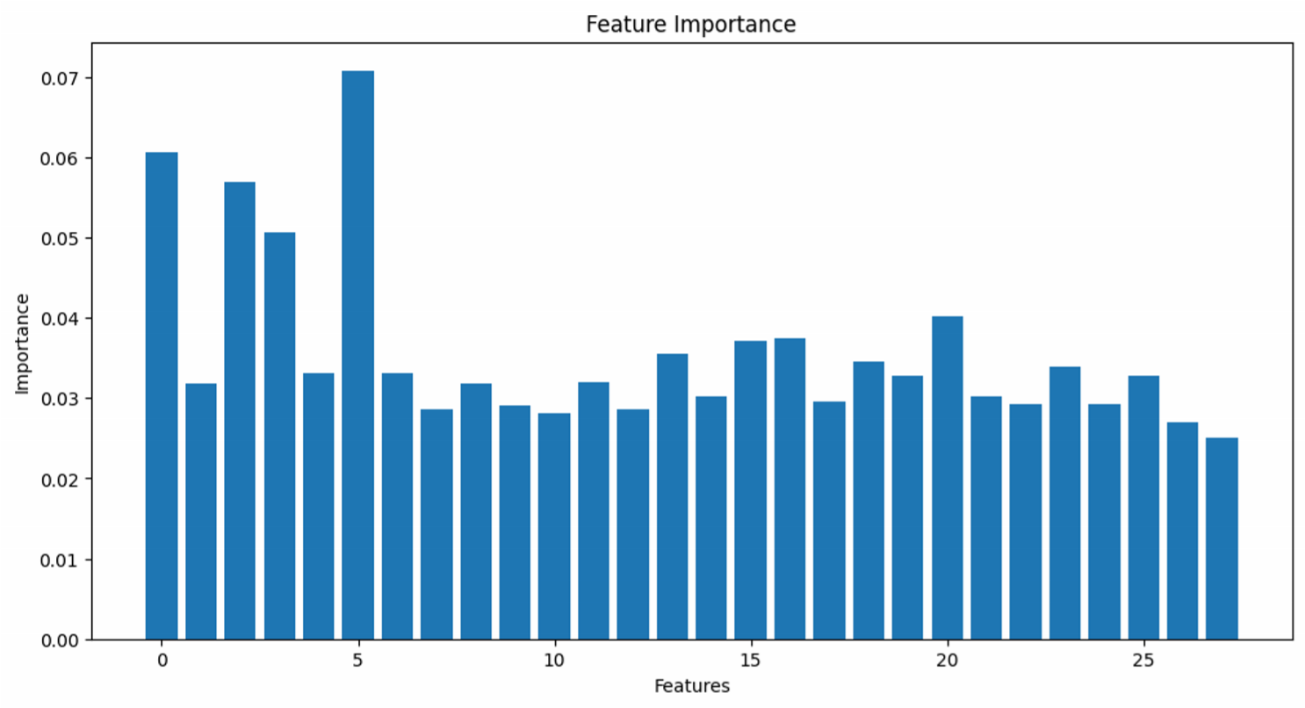

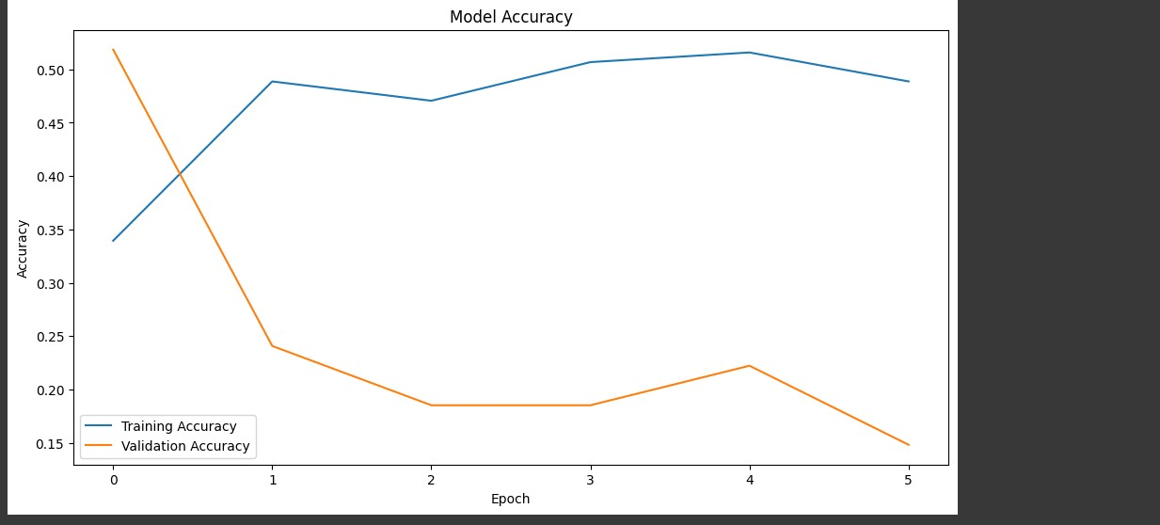

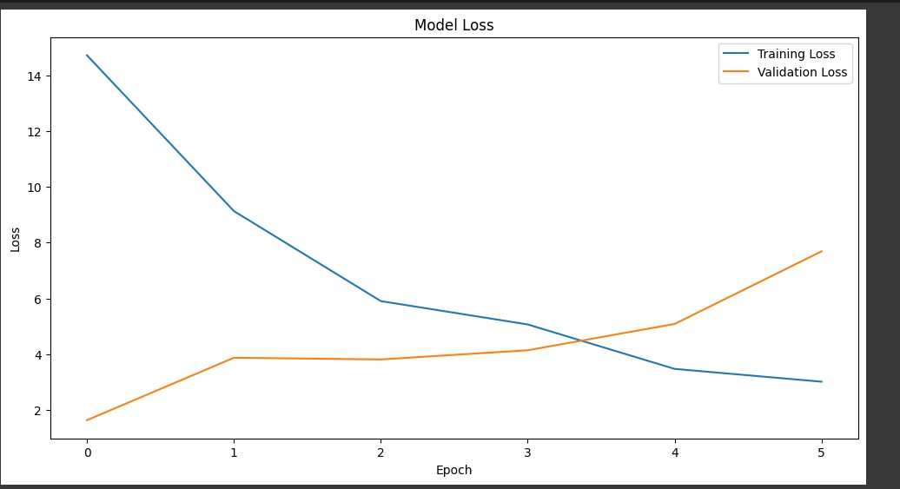

Conclusion  
This project successfully developed a deep learning-based system for classifying vehicles using a combination of data augmentation, feature engineering, and a pretrained ResNet50 model. The model achieved good validation accuracy and handled a wide range of image variations effectively. By applying techniques like transfer learning and regularization, the system addressed challenges such as class imbalance and overfitting. The results demonstrate the potential of deep learning models for practical applications in traffic analysis, intelligent transportation systems, and autonomous driving technologies.

## Colab Notebook Link:

[**https://colab.research.google.com/drive/12VA3dtmh3hbB723ob2jvHoi8dOnscUZe#scrollTo=V7lXFP2x2sxd**](https://colab.research.google.com/drive/12VA3dtmh3hbB723ob2jvHoi8dOnscUZe#scrollTo=V7lXFP2x2sxd)

GitHub Link:

<https://github.com/sadia59/CSE-Lab-Courses.git>

References :

https://www.kaggle.com/datasets/kaggleashwin/vehicle-type-recognition